­­­

|  |  |
| --- | --- |
| **LED MULTIPLEXING** | |
| **Name: Ashish Alva** | **Team Leader: Ullas Pai** |
| **USN: 4MT22EC011** |  |

**Aim:** Using MAX7219 library to generate different rolling LED patterns such as numbers, alphabets, scrolling text, symbols, emojis, etc. Apart from this, we can also display some sensor data like DHT11/DHT22 on this display for temperature and humidity.

**Components required:**

1. Arduino UNO Board
2. 8x32 Led Matrix using MAX7219 display
3. Jumper wires
4. Power supply
5. DHT11 sensor

**Procedure:**

1. Input connectors:
2. Connect the vcc(for external power supply) to the chip pin.
3. Connect ground pin(GND) to arduino.
4. Connect The Data pin(DIN).
5. Connect Load(CS/Load) to any pin of the microcontroller.
6. Connect clock pin(CLK) to any pin on the microcontroller.
7. Output connectors:
8. VCC connects to 5V on the next module.
9. GCC connects to GND on the next module.
10. DOUT is Data Out and connects to the DIN pin of the next module.
11. CS/LOAD  connects to CS / LOAD on the next module.
12. CLK  connects to CLK on the next module.
13. Downloading Arduino software/ using web version
14. Library Installation: MD_MAX72XX by MajicDesigns

Example 1: Code to display scrolling text

// Including the required Arduino libraries

#include <MD_Parola.h>

#include <MD_MAX72xx.h>

#include <SPI.h>

// Uncomment according to your hardware type

#define HARDWARE_TYPE MD_MAX72XX::FC16_HW

//#define HARDWARE_TYPE MD_MAX72XX::GENERIC_HW

// Defining size, and output pins

#define MAX_DEVICES 4

#define CS_PIN 3

// Create a new instance of the MD_Parola class with hardware SPI connection

MD_Parola myDisplay = MD_Parola(HARDWARE_TYPE, CS_PIN, MAX_DEVICES);

void setup() {

// Intialize the object

myDisplay.begin();

// Set the intensity (brightness) of the display (0-15)

myDisplay.setIntensity(0);

// Clear the display

myDisplay.displayClear();

myDisplay.displayScroll("Hello", PA_CENTER, PA_SCROLL_LEFT, 100);

}

void loop() {

if (myDisplay.displayAnimate()) {

myDisplay.displayReset();

}

}

**Circuit Diagram/ Schematics:**

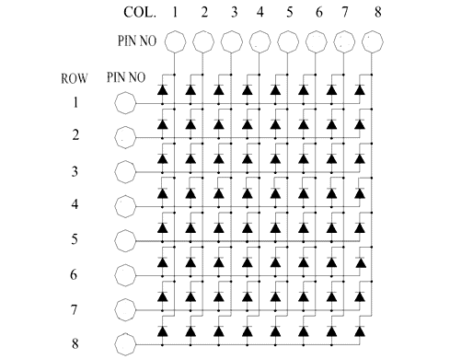

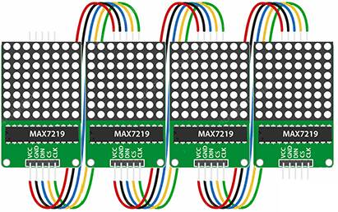

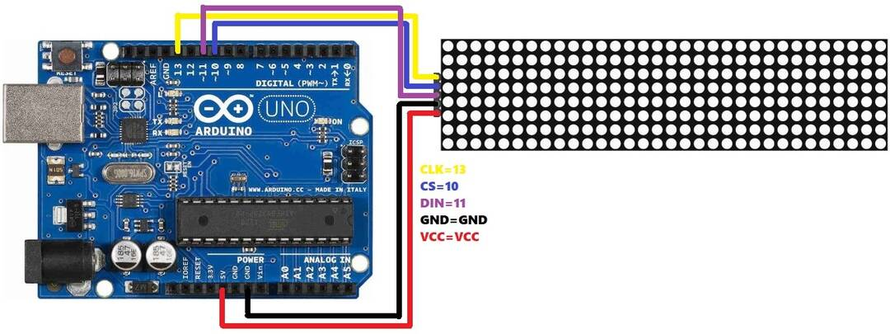

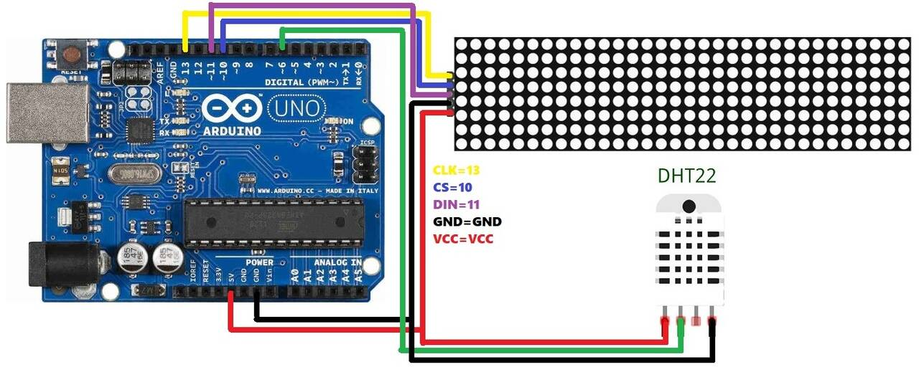

**Result:** Multiplexing is a technique employed to operate LED matrices. By multiplexing, only one row of the LED matrix is activated at any one time this approach is required because one end of the LED(either the anode or the cathode) is tied to a single row.